- Re-read lines 1-9
List four things you learn about the wounded man. [4 marks]

- Look in detail at this extract from lines 10 – 18 of the Source.
The kid was pale, shivering, unconscious. Manuel stood by the bright green door of the clinic, waving his arm. The men brought the body through and set it on the table in the centre of the room.
Immediately she could see that it did not look good. The kid would almost certainly die. A big tearing laceration ran from his shoulder down his torso. At the edge of the wound, the flesh was shredded. At the centre, the shoulder was dislocated, pale bones exposed. A second slash cut through the heavy muscles of the thigh, deep enough to reveal the pulse of the femoral artery below. Her first impression was that his leg had been ripped open. "Tell me again about this injury," she said. "I didn't see it," Ed said. "They say the backhoe dragged him." "Because it almost looks as if he was mauled," Bobbie Carter said, probing the wound. Like most emergency room physicians, she could remember in detail patients she had seen even years before. She had seen two maulings. One was a two-year-old child who had been attacked by a Rottweiler dog. The other was a drunken circus attendant who had had an encounter with a Bengal tiger. Both injuries were similar. There was a characteristic look to an animal attack.
Bobbie Carter turned back to the injuries. Somehow she didn't think she was seeing mechanical trauma. It just didn't look right. No soil contamination of the wound site, and no crush injury component. Mechanical trauma of any sort-an auto injury, a factory accident-almost always had some component of crushing. But here there was none. Instead, the man's skin was shredded -ripped-across his shoulder, and again across his thigh. It really did look like a maul. On the other hand, most of the body was unmarked, which was unusual for an animal attack.

How does the writer use language to show the horror of the injuries and attack?

You could include the writer’s choice of:
- Words and phrases
- Language features and forms [8 marks]

- You now need to think about the whole of the Source.
This text is from the opening of a novel. How has the writer structured the text to interest you as a reader?
You could write about:
- What the writer focuses your attention on in the beginning
- How and why the writer changes the focus as the Source develops
- Any other structural features that interest you. [8 marks]

- Focus this part of your answer on the second part of the Source from line 19 to the end.

A student, having read this section of the text, said: “The writer creates a tragic situation and hints at danger” To what extent do you agree?

In your response you could:
- Write about your own impressions of the situation being presented
- Evaluate how the writer has created these impressions
- Support your opinions with reference to the text [20 marks]

Section B: Writing

You are advised to spend about 45 minutes on this section.
Write in full sentences.
You are reminded of the need to plan your answer.
You should leave enough time to check your work at the end.

- A magazine has asked for contributions for their creative writing section.

Either

Write a description suggested by this picture:

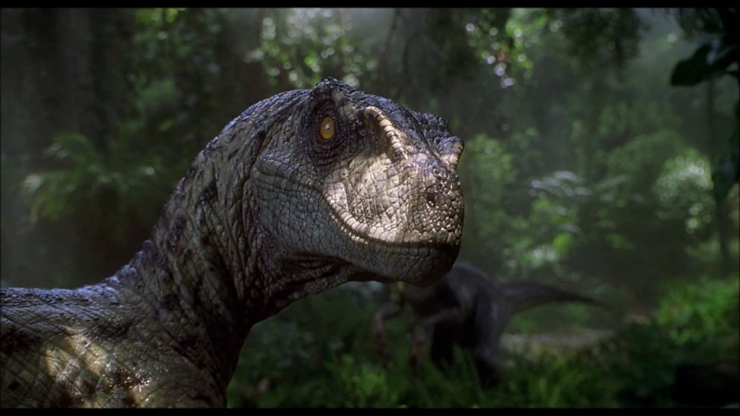

Or

Write a story that ends with “He thought it was the end of it. He thought he was safe. How wrong he was.”

(24 marks for content and organisation
16 marks for technical accuracy)
[40 marks]

